**Experiment No.1**

**Aim:-** Installation and setup of java development kit(JDK), setup android SDK, setup Android IDE, setup android development tools (ADT) plugins, create android virtual device.

**Requirements:-**

1. JDK 8 or later version.
2. Java Runtime Environment (JRE)6.
3. Download an IDE

Android Studio/ Eclipse/ Netbeans

But officially Android Studio is the recommended IDE for developing Android Projects.

**Installation:-**

* Install JDK and JRE in your system.
* Launch Android Studio exe.

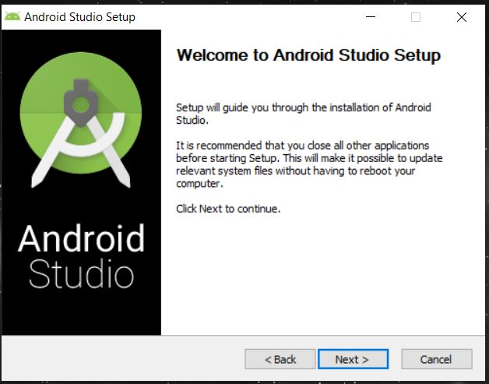

* If the JDK is not detected automatically you need to mention its path explicitly.
* Proceed further to include all the components.

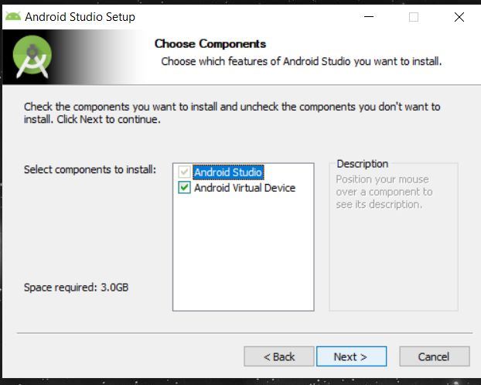

* Click Next. Untill you complete the installation.

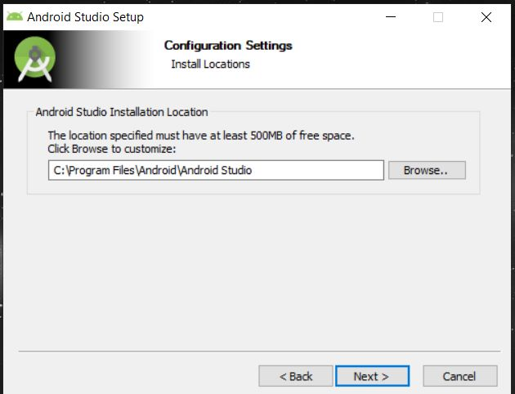

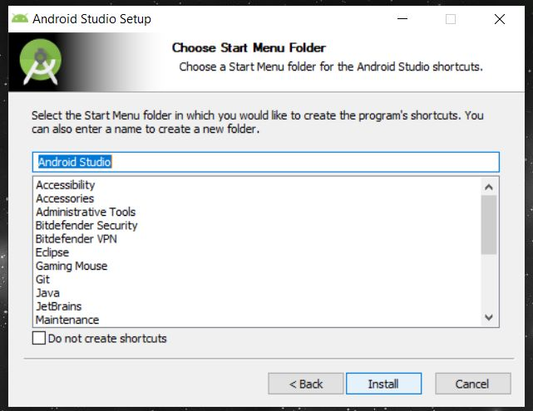

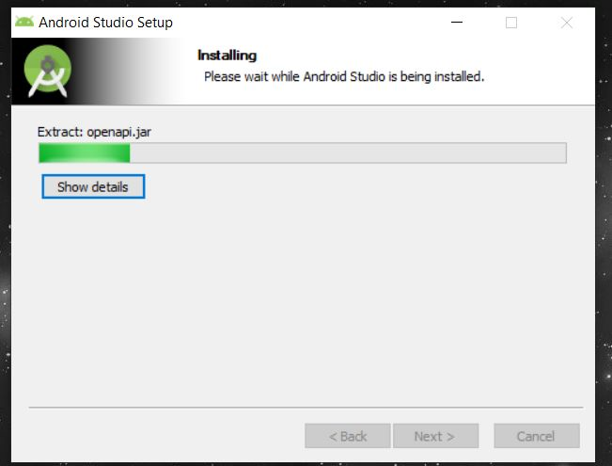

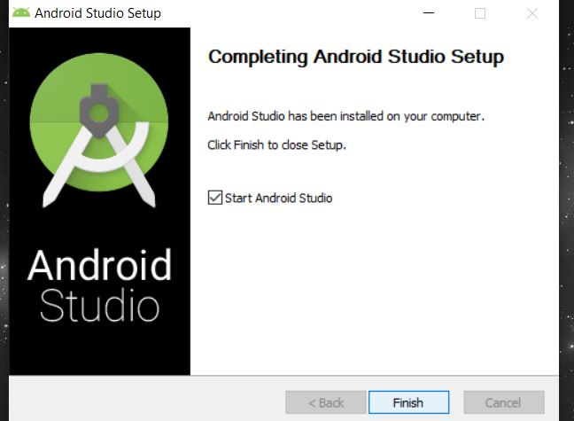

**Developer’s Option:-**

For activating Developer’s option in Android we need to navigate to **“Build Number”**  and tap **7 times.**

Generally, Goto **Settings>General>About Phone.**

Then Scroll and Select **Software information > Build Number.**

Now rapidly tap on ‘Build Number’ seven times and you will see the message

**‘You are now a developer!’**

When the Developer options are unlocked, you should see something like this:

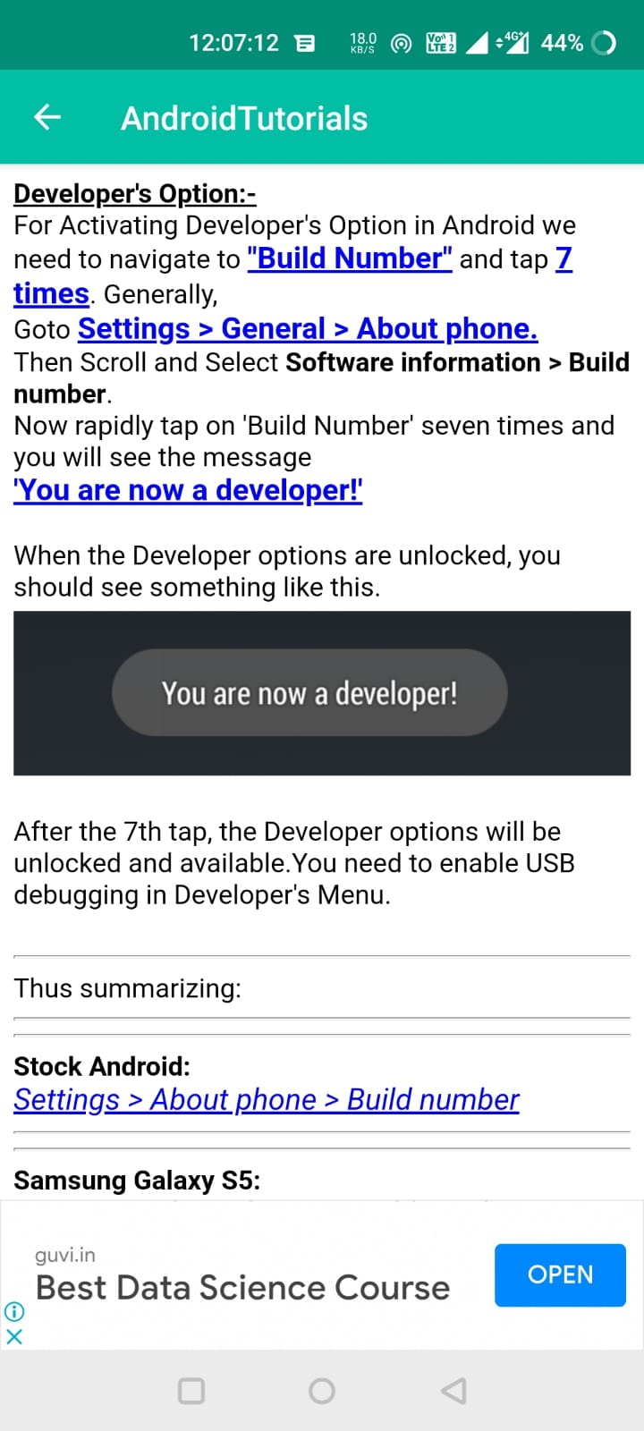

After the 7th tap, the Developer options will be unlocked and available. You need to enable USB debugging in Developer’s Menu.

**Conclusion:**

Hence by completing this experiment I came to know about Installation and setup of java development kit(JDK), setup android SDK, setup Android IDE, setup android development tools (ADT) plugins, create android virtual device.

|  |  |  |  |
| --- | --- | --- | --- |
| **Writeup & Oral**  **(4)** | **Practical Performance**  **(4)** | **Attendance**  **(2)** | **Total**  **(10)** |
|  |  |  |  |